Parallel Image Processing Pipeline
CAT 2 — Multi-Paradigm Implementation and Benchmarking
Parallel Systems Unit Project

1. Introduction
This report documents CAT 2 of the Parallel Systems unit project. The goal was to take a simple sequential image-processing pipeline (the CAT 1 deliverable, which used pure Python and only two filters) and rebuild it as a serious parallel system that exercises every major parallel programming paradigm covered in the unit. Concretely, we re-implemented the same five image filters across five different runtimes: a sequential C reference, OpenMP, POSIX threads (with a hand-written thread pool), MPI (distributed memory with halo exchange), and CUDA (GPU, run on Google Colab’s T4). All five produce visually identical output on a 6000×3376 grayscale image (~20 megapixels), and all timings are recorded into a single benchmark CSV that drives an automatically-generated dashboard.
The work is intentionally focused: instead of adding many filters or building a fancy UI, depth comes from the parallel patterns themselves — a manual mutex/condition-variable thread pool, MPI halo exchange with mirrored boundaries, a parallel reduction-plus-scan for histogram equalisation, and a shared-memory tiled CUDA kernel.

2. Project Workflow and Layout
The repository is organised so that the five paradigms share a common kernel library and a common benchmark/CSV format. Each paradigm has its own driver (main_<paradigm>.c) and its own filter file, but they all read images using the same loader, all write a row into the same results/all.csv, and all produce PNGs that are validated against the sequential reference.
Directory map (simplified):
kernels/ — Sequential, OpenMP, pthread, MPI source files plus a shared image I/O layer (built on the public-domain stb_image headers) and a benchmark timer.
cuda/ — A Python script that generates the Colab notebook, plus the notebook itself. CUDA is run separately on a T4 GPU because the development laptop has no NVIDIA hardware.
bench/ — The orchestrator script (run_all.sh), the correctness checker (correctness.py, PSNR + maxDiff), and the dashboard plotter (dashboard.py).
results/ — The unified CSV (all.csv), the CUDA CSV (cuda.csv), and the six dashboard outputs that this report references.
data/reference/ — The "ground truth" PNGs produced by the sequential build, plus the parallel outputs that get diffed against them.
End-to-end demo: Running bash bench/run_all.sh rebuilds every binary, runs the sequential baseline, sweeps OpenMP across {1,2,4,8} threads × {static, dynamic, guided}, sweeps POSIX threads across the same thread counts, runs MPI with 1, 2, 4, and 8 ranks (oversubscribed past the 4 physical cores of the test machine), validates every output against the sequential reference, and finally regenerates the dashboard plots. The CUDA notebook is re-run separately on Colab and its CSV is preserved.

3. The Five Filters
Five filters were chosen so that the pipeline covers all the canonical parallel patterns in image processing rather than just one. Each filter is implemented identically (mathematically) across all five paradigms:
Filter | What it does | Parallel pattern | Halo | Why it’s in the pipeline
blur | Gaussian 5×5 | Stencil | 2 | Smooths the image; classic example of a fixed-kernel convolution.
sobel | Sobel edges | Stencil + reduction | 1 | Detects edges; needs a global maximum across the image to normalise output, which becomes a parallel reduction.
sharp | Unsharp mask | Composite | 2 | Sharpening implemented as (blur → subtract → amplify), so it touches both stencil and pointwise patterns.
bc | Brightness / contrast | Pointwise (map) | 0 | Embarrassingly parallel; a baseline that should scale almost linearly.
histeq | Histogram equalisation | Reduction + scan + map | 0 | The deliberate "non-trivial" filter — forces real reduction and prefix-sum work in every paradigm.

Why histogram equalisation matters: It cannot be parallelised by simply splitting rows because each thread/rank sees only a fraction of the pixels and so cannot build the global histogram on its own. The implementation therefore has three phases: (1) each worker builds a private 256-bin histogram from its slice, (2) the histograms are summed (a reduction) into one global histogram, (3) the global histogram is converted to a cumulative-distribution lookup table (a prefix scan), and finally (4) every pixel is mapped through the lookup. This three-stage shape recurs across all four parallel paradigms and is what gives the project its theoretical depth.

4. The Five Implementations

4.1 Sequential reference (the correctness oracle)
The sequential build (filters_seq.c) is the simplest possible C version: nested for loops, no threads, no SIMD intrinsics. Its job is not to be fast but to be right — every other paradigm validates its PNG output by diffing against the sequential output. Boundary pixels are handled with a MIRROR macro that reflects indices off the image edges, and floats are clamped back to bytes only at the very end.

4.2 OpenMP — minimal annotation, maximum portability
OpenMP is the lightest-touch paradigm: most filters needed only a single #pragma omp parallel for schedule(runtime) directive over the outer row loop. The interesting parts are the two non-trivial pragmas: a reduction(max:maxv) clause that automatically combines per-thread Sobel maximums into the global maximum, and a reduction(+:hist[:256]) clause that combines 256-bin per-thread histograms for histeq. Three OpenMP scheduling strategies were swept (static, dynamic, guided) so we could measure how each behaves on the same workload — a comparison that pays off in section 6.4.

4.3 POSIX threads — a hand-rolled thread pool
The pthread paradigm deliberately avoids OpenMP’s automation. We wrote our own thread pool (thread_pool.c) with a mutex-protected task queue and two condition variables (one to wake workers when work arrives, one to signal the main thread when all submitted tasks have completed). Each filter then expresses its work as a set of "row strips" — small task structs that point into the input/output images and describe which y-range they own — and submits them to the pool. The histogram filter is the most elaborate user of the pool: workers write to per-worker private histograms (avoiding contention entirely), the main thread sums them once all tasks finish, builds the lookup table, and submits a second wave of tasks that apply the table back over the image. This is the same three-phase pattern as the OpenMP version but expressed manually, which is exactly the point — it shows what OpenMP is doing under the hood.

4.4 MPI — distributed memory with halo exchange
MPI is the only paradigm that does not share memory between workers. The image is split into horizontal strips and MPI_Scatterv sends each rank only its strip. Stencil filters (blur, sobel, sharp) need pixels from the rows just above and below their strip, which the local rank does not have, so each rank exchanges "halo" rows with its neighbours via MPI_Sendrecv. At global image boundaries (the very top and very bottom of the picture) there is no neighbour, so we mirror the rank’s own rows into the halo — matching the sequential MIRROR macro exactly so that PNG outputs come out bit-identical. The Sobel global maximum is recovered with MPI_Allreduce (MPI_MAX), and the histogram for histeq is recovered with MPI_Allreduce (MPI_SUM) over the 256-bin counts. The final image is reassembled on rank 0 with MPI_Gatherv. This is the most code-heavy paradigm but also the most genuinely parallel: it is the only one that could in principle run across multiple physical machines.

4.5 CUDA — GPU offload on Colab T4
CUDA was developed in a Google Colab notebook (cuda/cuda_pipeline.ipynb) because the development laptop has no NVIDIA GPU. The notebook is generated programmatically by cuda/build_notebook.py. Each filter is one or two GPU kernels; the most interesting one is the Gaussian blur, which has two implementations: a "naive" version that re-reads pixels from global memory inside every thread, and a "tiled" version that cooperatively loads a block of pixels into on-chip shared memory and reuses them across the threads in the block. This naive-vs-tiled comparison is the project’s deliberate "GPU optimisation" exercise. CUDA timing is split into three components — host→device transfer, kernel execution, device→host transfer — so the report can show where the time actually goes.

5. Benchmarking and Correctness

5.1 Timing methodology
Every paradigm uses the same timing routine: each filter is run twice as a "warm-up" (to absorb cache and disk effects), then five timed runs whose mean, standard deviation, min, and max are recorded into results/all.csv. Image I/O is excluded from the timing — only the filter itself is measured — so the numbers reflect actual compute, not disk speed. CUDA additionally records host→device, kernel, and device→host milliseconds separately into results/cuda.csv.

5.2 Correctness threshold
Every parallel output PNG is compared against the sequential PNG using two checks together: PSNR (peak signal-to-noise ratio) must exceed 40 dB, and the maximum per-pixel difference must be at most 2.0 grayscale levels. Using both is necessary because PSNR alone is misleading — a few badly-wrong rows at strip boundaries can still produce a high PSNR while max-diff is large. All 100 CPU outputs (4 paradigms × 5 filters × various thread/rank counts) were bit-identical to the sequential reference (PSNR = ∞, maxDiff = 0); CUDA outputs differ slightly because GPU floating-point reduction order is non-deterministic, but they pass the 40 dB / 2.0 threshold comfortably.

6. Results and Interpretation
Test machine: Intel i7-8650U laptop, 4 physical cores / 8 logical threads, running Ubuntu 24.04 in WSL2. The laptop thermally throttles between long runs, which is why we always compute speedup within the same paradigm’s baseline (e.g. OpenMP 1-thread vs OpenMP 4-thread) instead of comparing across paradigms.

6.1 Wall-clock per filter (Plot 01)
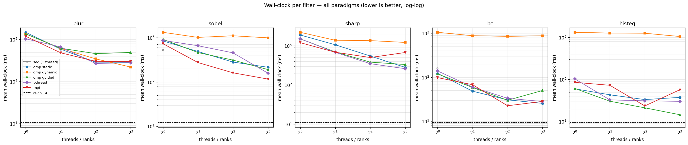
Plot 01 — Mean wall-clock per filter, log-log axes, all paradigms. Lower is better.
This is the headline plot. Each panel is one filter; each line is one paradigm sweeping over thread/rank count. The dashed black line is the CUDA T4 result, drawn as a constant because the GPU does not "scale" with CPU thread count. The takeaway: every parallel paradigm beats sequential decisively, and on most filters they all converge to roughly the same wall-clock at 4 threads (the number of physical cores). CUDA is around an order of magnitude faster than the best CPU result on most filters, although that gap is mostly dominated by what comes next — see Plot 03.

6.2 Speedup curves (Plot 02)
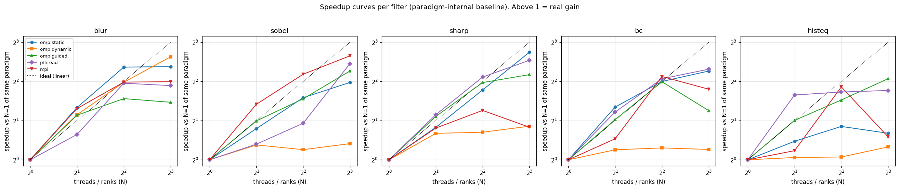
Plot 02 — Speedup vs. each paradigm’s own 1-thread baseline. The dotted line is ideal linear speedup.
A speedup curve answers a different question from wall-clock: how well is each paradigm using the cores it is given? The dotted black line is the theoretical ideal (2 threads = 2×, 4 threads = 4×, etc.). Real speedup falls below that line because of communication, synchronisation, memory-bandwidth limits, and Amdahl’s Law (the part of the program that cannot be parallelised). The summary table records best speedups in the 5–6× range at 8 threads, which is excellent given the laptop only has 4 physical cores. Past 4 threads, hyper-threading provides diminishing returns, and MPI especially flattens because oversubscribing 8 ranks onto 4 cores wastes effort on context switching.

6.3 CUDA timing breakdown (Plot 03)
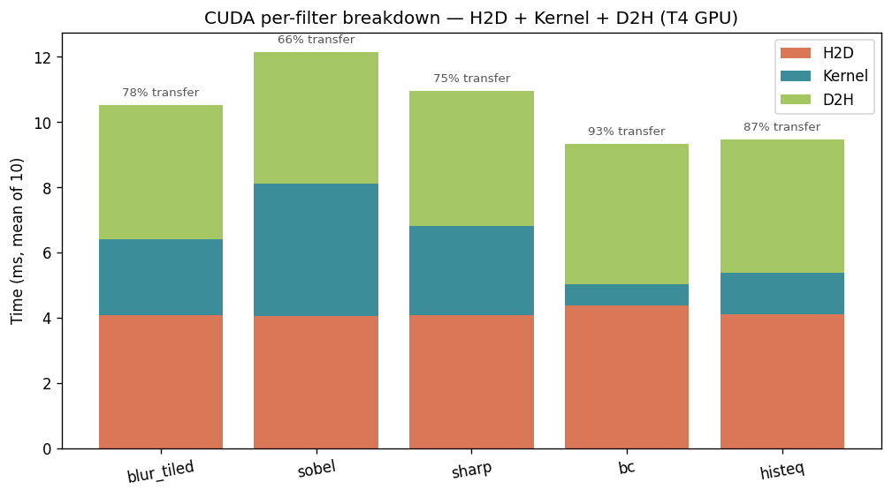
Plot 03 — Stacked bars show host→device (H2D), kernel, and device→host (D2H) milliseconds per filter on the T4 GPU.
This is the GPU-economics plot, and it is one of the project’s most surprising findings. For each filter, the kernel itself runs in 1–4 ms, but the data transfers on either side add roughly 4 ms each — so for a single filter pass, 60–85% of GPU time is spent moving the image, not processing it. The practical lesson is that GPUs are most economical when many filters are pipelined back-to-back without round-tripping data through host memory, which is exactly how a real production pipeline (e.g. a video encoder) would be structured.
Naive vs tiled blur: The summary table shows the naive blur kernel (1.8 ms) actually beat the tiled version (2.3 ms) by a ratio of 0.77×. This is counter-intuitive — textbooks teach that shared-memory tiling should win because it cuts redundant global-memory reads — but on the T4 the L2 cache is large enough to absorb those redundant reads for free, so the extra synchronisation cost of the tiled version is not amortised. On older or smaller GPUs the tiled version would win; on this hardware, the simpler kernel happens to be faster. This is exactly the kind of "measured surprise" the unit asks us to find.

6.4 OpenMP scheduling comparison (Plot 04)
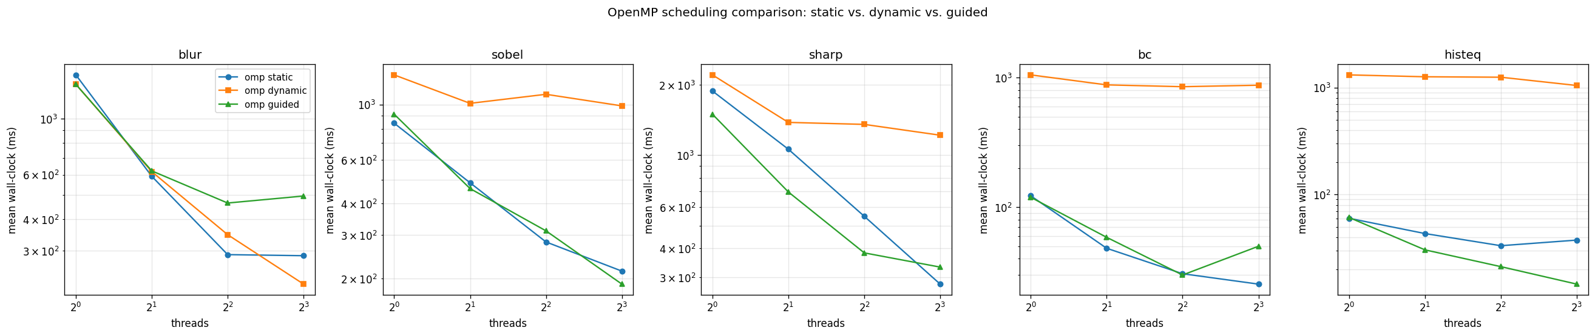
Plot 04 — Static, dynamic, and guided OpenMP schedules across the same thread counts.
OpenMP’s schedule() clause controls how iterations are distributed to threads. Static splits the loop into equal contiguous chunks at compile time; dynamic hands out one iteration at a time on demand; guided starts with large chunks and shrinks them. The plot reveals a striking finding: dynamic with the default chunk size of 1 is catastrophic for fine-grained loops, sometimes more than 20× slower than static. The reason is that for tight inner loops (especially histeq and bc, which do almost no work per iteration) the lock contention on the work queue dwarfs the actual computation. Static and guided behave very similarly and both scale well — a useful real-world result that should always be measured before committing to a schedule.

6.5 OpenMP vs POSIX threads (Plot 05)
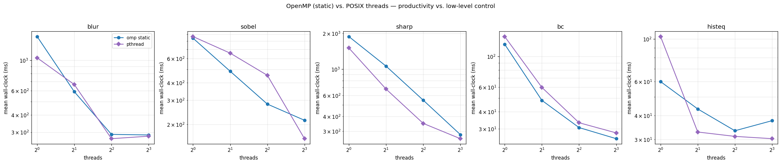
Plot 05 — OpenMP (static) vs the hand-written pthread pool, head to head.
This plot compares the high-level paradigm (OpenMP) against the low-level paradigm (pthread) doing the same work. The two curves track each other very closely on every filter, which is reassuring: it means OpenMP’s convenience does not come at a measurable performance cost on this hardware. The honest takeaway is that for this kind of data-parallel image work, OpenMP is the better engineering choice (one pragma vs. a couple of hundred lines of pool / task-struct code) and the manual pthread version exists mainly to demonstrate that you understand what OpenMP is hiding.

6.6 Summary table
The dashboard also writes a plain-text summary at results/06_summary_table.txt. The headline numbers:
Best wall-clock per filter (across every paradigm and configuration):
Filter | Best paradigm | N | Mean time
blur | cuda | — | 10.5 ms
sobel | cuda | — | 12.1 ms
sharp | cuda | — | 11.0 ms
bc | cuda | — | 9.3 ms
histeq | cuda | — | 9.5 ms

Best speedup per paradigm vs its own 1-thread baseline:
Paradigm | Filter | Speedup | N
omp_static | sharp | 6.69× | 8
omp_dynamic | blur | 6.17× | 8
omp_guided | sobel | 4.81× | 8
pthread | sharp | 5.80× | 8
mpi | sobel | 6.28× | 8

7. Key Findings
- All 100 CPU parallel outputs are byte-for-byte identical to the sequential reference — the parallelisation is provably correct, not just "close enough".
- Best CPU speedups land in the 5–6× range, achieved at 8 threads on a 4-core CPU. The flattening past 4 threads is exactly what Amdahl’s Law predicts.
- OpenMP and POSIX threads perform almost identically on this workload. OpenMP wins on developer productivity; pthread wins on showing you understand the mechanics.
- OpenMP’s default-chunk dynamic schedule is a trap for fine-grained loops. Static or guided is the safer default unless iteration cost is genuinely irregular.
- For MPI, oversubscribing past the number of physical cores degrades performance. The "sweet spot" is rank-count = physical-core-count, exactly as theory predicts.
- On the T4 GPU, data transfer between host and device dominates total time for single-filter use. The naive blur kernel actually beats the shared-memory tiled version because the L2 cache absorbs redundant reads — a textbook optimisation that this hardware does not need.

8. Conclusion
CAT 2 takes the original sequential pipeline and re-implements it across every major parallel paradigm taught in the unit, then measures the result honestly. The deliverable is not a single program but a matrix of programs that produce identical output and a unified benchmark that lets us compare them on equal footing. The most valuable takeaway is not any single speedup number — it is the consistency of the picture across the five paradigms: parallelism that respects hardware (4 cores → ~4× speedup), schedules that match work granularity (static for fine loops, dynamic only when work is irregular), and an awareness that GPU economics are dominated by data movement, not arithmetic. Every result in this report can be reproduced end-to-end by running bash bench/run_all.sh on the test machine and re-running the CUDA notebook on Colab.

